DNS and Route 53 for Domain Management

Practical on Route53
1.Create a Instance
- Name -----------------> webserver
- Instance type -------> t3. micro
- Ami --------------------> ubuntu
- Create a instance

2.Access The Instance
- apt update
- apt install apache2 -y
- systemctl start apache2
- cd /var/www/html/
- rm -rf index.html
- vim index.html
<h1> Hello World </h1>
- systemctl restart apache2

3.Check It on The Browser
<public_ip>

4.Go To Route 53 & Create A Hosted Zone
- create a hosted zone
- name -------------> mayurcbz.space
- zone --------------> public hosted zone
- create a hosted zone

5.Add Nameservers on The Hostinger
- copy these 4 nameserver from the hosted zone
- Hostinger -> Domain -> Domain portfolio -> Domain name -> DNS nameservers -> change nameservers -> delete all the nameservers -> add our copied nameservers -> save
- Wait for up to 10 minutes or 24 hours to update the nameservers
6.Go to Route 53
- Click on hosted zone
- Create a record
- Record name --------> (empty)
- Record type ----------> A
- Value -------------------> <server public_ip)
- Routing policy -------> simple routing policy
- Create a record

ROUTING POLICY
1.Simple Routing Policy
- This policy is used when you have only one resource, like a single server or website.
- Route 53 simply returns the same IP address every time without any decision-making.
- It does not support load balancing or failover, so it’s very basic.
- Best suited for small or static websites where high availability is not required.

2.Failover Routing Policy
- This policy is designed to provide high availability by using a primary and a backup resource.
- Route 53 continuously checks the health of the primary server using health checks.
- If the primary fails, traffic is automatically redirected to the secondary (failover) server.
- It ensures your application remains accessible even during failures.
- Example
- 10.0.0.0 --------> primary server (active server)
- 20.0.0.0 --------> secondary server (passive server)

3.Weighted Routing Policy
- This policy allows you to split traffic between multiple resources based on assigned weights.
- For example, you can send 80% of traffic to one server and 20% to another.
- It is commonly used for testing new versions of applications (A/B testing).
- Helps in gradual traffic shifting without affecting all users at once.
- Example:
- 10.0.0.0 -------------> 50%
- 20.0.0.0 -------------> 60%
- 30.0.0.0 -------------> 20%

4.Latency Based Routing Policy
- This policy routes users to the AWS region that provides the lowest network latency.
- It improves the speed and performance of your application for global users.
- Route 53 makes decisions based on real-time latency measurements.
- Ideal for applications where fast response time is critical.

5.Geolocation Routing Policy
- This policy routes traffic based on the geographic location of the user (country or continent).
- It allows you to serve region-specific content, such as language or legal restrictions.
- You can also restrict access from certain locations if needed.
- Useful for businesses that target different audiences in different regions.
- Example:
  - 10.10.10.10 ------> India ----> Hindi
  - 20.20.20.20 ------> US -------> Japanese
  - 30.30.30.30 ------> Japan ---> English

6.Geoproximity Routing Policy
- This policy routes traffic based on the distance between users and your resources.
- You can adjust traffic flow using a bias value to increase or decrease traffic to a region.
- It provides more control compared to geolocation routing.
- Commonly used for balancing traffic across multiple geographic regions.

7.Multi-Value Answer
- This policy returns multiple IP addresses instead of just one.
- Route 53 only returns healthy resources, improving reliability.
- It works like a simple load balancing mechanism.
- Helps increase availability and fault tolerance of applications.
- Example:
- 10.0.0.0
- 20.0.0.0
- 30.0.0.0
- 40.0.0.0
- So I have added 4 servers in the backend so users get the response randomly from any of the server but only from the healthy server.

8.IP-Based Routing Policy
- This policy routes traffic based on the client’s IP address range (CIDR blocks).
- You can define custom rules for specific networks or users.
- Useful for security, compliance, or internal routing needs.
- Helps deliver personalized or restricted access based on IP ranges.

ROUTE-53 WITH LOAD BALANCER & WAF & CREATING SSL CERTIFICATE

1.Create A Instance
1.nam --------> app1
2.machine ---> amazon-linux
3.az--------1a
4.sg--------http,https,ssh
5.useradata-
#!/bin/bash
sudo yum update -y
sudo yum install httpd -y
sudo systemctl start httpd.service
sudo systemctl enable httpd.service
sudo echo "SERVER-1" > /var/www/html/index.html
sudo systemctl restart httpd.service
6.create a instance

2.Create A Instance
1.name----app2
2.machine---amazon-linux
3.az--------1b
4.sg--------http,https,ssh
5.useradata-
#!/bin/bash
sudo yum update -y
sudo yum install httpd -y
sudo systemctl start httpd.service
sudo systemctl enable httpd.service
sudo echo "SERVER-2" > /var/www/html/index.html
sudo systemctl restart httpd.service
6.create a instance

3.Create A Target Group
- Type------> instance
- name-----> tg
- path-----/
- register---> 1.app1
2.app2
- create a target group

4.Create A Load Balancer
- name----ALB
- vpc-------default
- az-----1a,1b,1c
- sg-----our instance sg
- forward to ----> tg
- create a load balancer

5.Go To Route-53
1.create a hosted zone
2.copy the all name-server and paste it on the Hostinger account

6.Go To Hostinger
- Go to Domain → Nameservers
- Replace with Route 53 NS records

7.Create Alias Record In Route53
1.create a record
- name------------> (empty)
- route traffic---> alias
- endpoint--------> (region-name ---> load balancer dns name)
- policy----------> simple routing
- create a record

8.Check It On The Web
http://mayurcbz.space

9.Create ACM (SSL) Certificate
1.request certificate
2.domain------> mayurcbz.space
3.Validation → DNS
3.request a certificate
4.view certificate
5.create a record in route-53
6.check status -----> Issued

10. Add HTTPS to Load Balancer
- add listener
- add port ---------> https-443
- Forward to -----> tg
- add acm ----> (certificate-mayurcbz.space)

11. Redirect HTTP → HTTPS
1.edit already created listener -> 80
2.redirect to URL ------> https --> (443)
3.save

12.Check It On The Web
{ https://mayurcbz.space/ }

13.Creating A WAF For Load Balancer
1.Create A IP Set
- IP set name -----------> my-ip-set
- scope -------------------> regional
- ip version --------------> IPv4
- ip address -------------> (my system ip address/32 – find my ip address)
- save
2.Create A WEB ACL
- app category ---------> others
- app focus --------------> web
- add resource ----> add regional resource ----> select ALB ----> add
- click on recommended rules for u
- name --------------> my-web-acl
- create a web acl
3.Create A Rule
- click on my-web-acl
- click on manage rule ----------> add rule
- custom rule ---> Next
- ip based rule ----> Next
- Action -------------> Block
- Rule name -------> my-rule
- Statement -------> Use existing IP set -------> my-ip-set
- Add rule

Note:
- At these time u have been block u get the 403 forbidden error
4.Change the rule
1. click on my-web-acl
2. click on manage rule -------> my-rule
3. Action ------> captcha
4. If a request -----> does not match the statement (NOT)
5.inspect -----------> originates from an ip address in -------> my-ip-set
6.save rule

Note:
- At this time all the users get the captcha first before going into the website but only your ip directly go the website

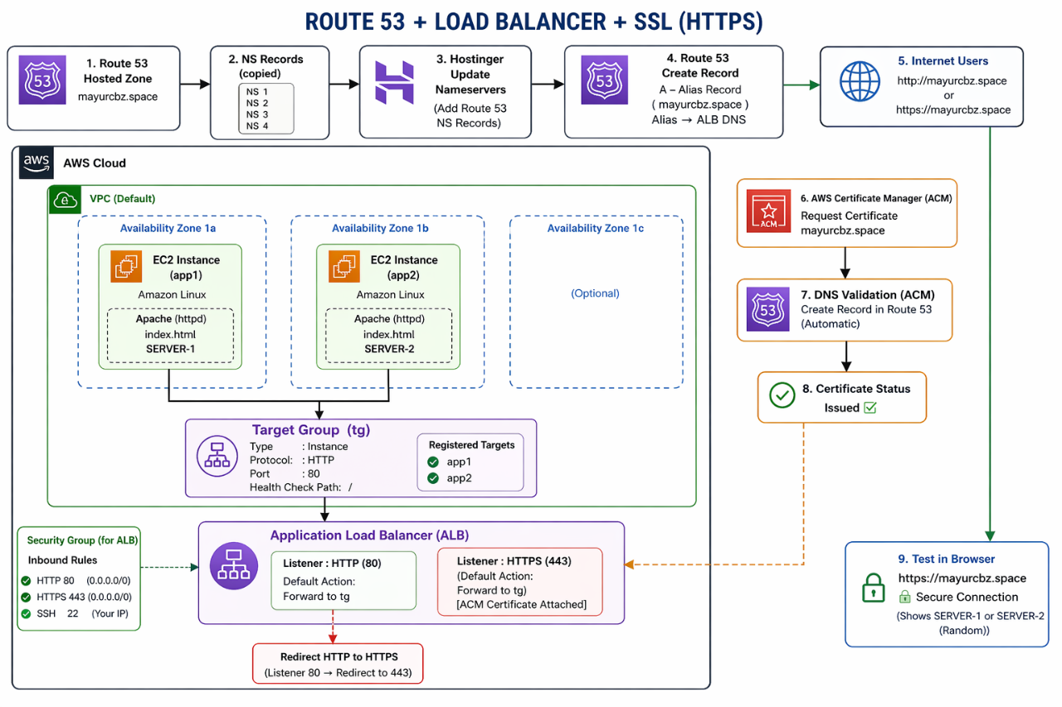

MULTI-REGION DISASTER RECOVERY WITH EC2 AND FAILOVER ROUTING

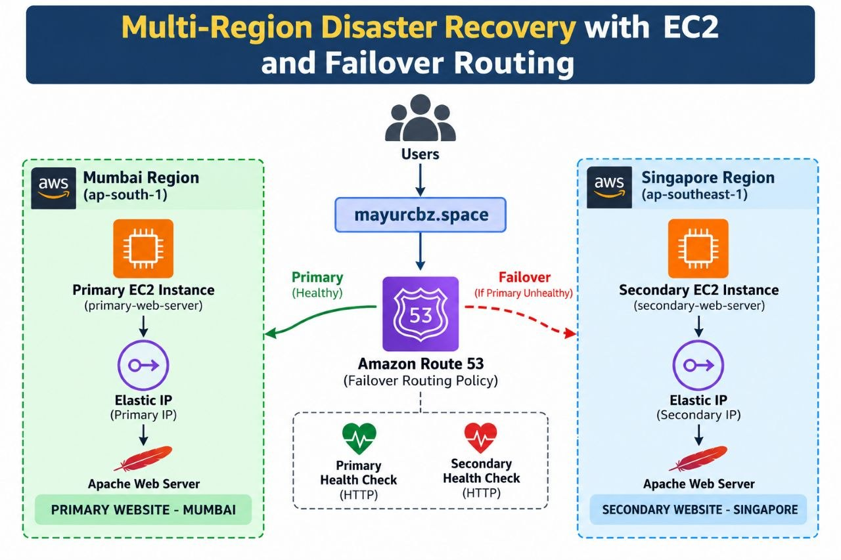

LAUNCH PRIMARY EC2 INSTANCE IN MUMBAI
1.create a instance
- name - primary-web-server
- ami - ubuntu
- instance_type - t3.micro
- key_pair - mayur
- sg - ssh/http
- user_data
#!/bin/bash
sudo apt update
sudo apt install apache2 -y
echo '<h1>PRIMARY WEBSITE - MUMBAI</h1>' | sudo tee /var/www/html/index.html
sudo systemctl enable --now apache2
- launch ec2 instance

2.Allocate Elastic IP Address
- click on elastic ip address
- allocate elastic ip address
- associate IP with primary-web-server

LAUNCH SECONDARY EC2 INSTANCE IN SINGAPORE
1.create a instance
- name - secondary-web-server
- ami - ubuntu
- instance_type - t3.micro
- key_pair - mayur
- sg - ssh/http
- user_data
#!/bin/bash
sudo apt update
sudo apt install apache2 -y
echo '<h1>SECONDARY WEBSITE - SINGAPORE</h1>' | sudo tee /var/www/html/index.html
sudo systemctl enable --now apache2
- launch ec2 instance

2.Allocate Elastic IP Address
- click on elastic ip address
- allocate elastic ip address
- associate IP with secondary-web-server

ROUTE53
CREATE THE PRIMARY AND SECONDARY HEALTH CHECK
1.create a health check
- name - primary-mumbai-health
- monitor - endpoint
- endpoint - IP address
- protocol - HTTP
- IP address - (primary-elastic-ip-address/)
- create health check

2.create a health check
- name - secondary-singapore-health
- monitor - endpoint
- endpoint - IP address
- protocol - HTTP
- IP address - (secondary-elastic-ip-address/)
- create health check
ROUTE53
CREATE THE PRIMARY & SECONDARY FAILOVER RECORD
1.click on record
- record name - leave blank
- record type - A
- value - (primary-elastic-ip-address)
- routing policy - failover
- failover record type - primary
- Health check - primary-mumbai-health
- Record ID - (paste primay-mumbai-health-id)
- create record

1.click on record
- record name - leave blank
- record type - A
- value - (secondary-elastic-ip-address)
- routing policy - failover
- failover record type - secondary
- Health check - secondary-singapore-health
- Record ID - (paste secondary-singapore-health-id)
- create record

TEST
- http://mayurcbz.space
( you get only the primary Mumbai server)

SIMULATE PRIMARY FAILURE
- Connect to the Mumbai primary EC2 and run:
- sudo systemctl stop apache2

TEST
- http://mayurcbz.space
( you get the secondary server )

RESTORE THE PRIMARY AND TEST FAILBACK
On the Mumbai primary EC2 instance, run:
- sudo systemctl start apache2
- sudo systemctl status apache2
TEST
- http://mayurcbz.space
- ( you get back to Primary server )

HOW DO WE REDUCE DOWNTIME

Improve Route 53 failover
- Use a 60-second TTL.
- Use 10-second fast health checks if appropriate for your budget.
- Reduce the failure threshold cautiously.
- Keep the Singapore server running and ready.

AWS Global Accelerator
- Give users two static anycast IP addresses.
- Register endpoints in Mumbai and Singapore.
- Configure health checks and endpoint groups.
- Send new connections to healthy endpoints without relying on DNS TTL changes for each failover.

Active-active multi-Region architecture
- Run the application in both Regions.
- Send traffic to both healthy Regions.
- Design the database, sessions, and application state for cross-Region resilience.
- Add retries, timeouts, and graceful error handling.

WEIGHTED ROUTING POLICY FOR MULTI-REGION TRAFFIC DISTRIBUTION
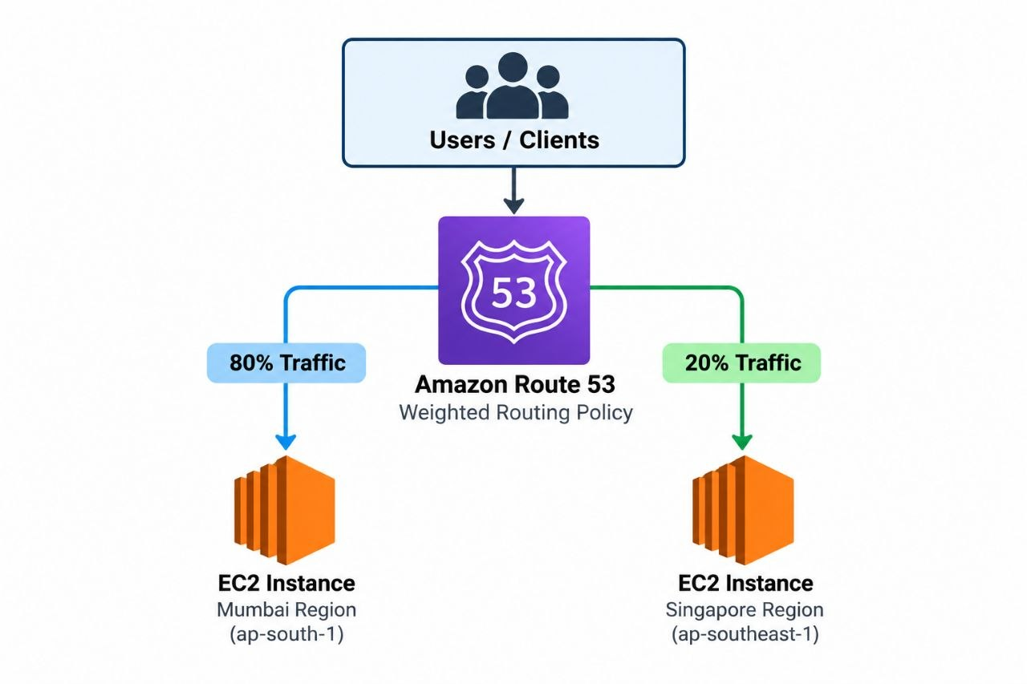

LAUNCH EC2 INSTANCE IN MUMBAI

- create a instance
- name - primary-web-server
- ami - ubuntu
- instance_type - t3.micro
- key_pair - mayur
- sg - ssh/http
- user_data
sudo apt update
sudo apt install apache2 -y
echo '<h1>PRIMARY WEBSITE - MUMBAI</h1>' | sudo tee /var/www/html/index.html
sudo systemctl enable --now apache2
- Launch ec2 instance

Allocate Elastic IP Address
- click on elastic ip address
- allocate elastic ip address
- associate IP with primary-web-server

LAUNCH EC2 INSTANCE IN SINGAPORE

- create a instance
- name - secondary-web-server
- ami - ubuntu
- instance_type - t3.micro
- key_pair - mayur
- sg - ssh/http
- user_data
sudo apt update
sudo apt install apache2 -y
echo '<h1>SECONDARY WEBSITE - SINGAPORE</h1>' | sudo tee /var/www/html/index.html
sudo systemctl enable --now apache2
- launch ec2 instance

Allocate Elastic IP Address
- click on elastic ip address
- allocate elastic ip address
- associate IP with secondary-web-server

ROUTE53
CREATE THE MUMBAI WEIGHTED RECORD

click on record
- record name - weighted
- record type - A
- value - (mumbai-elastic-ip-address)
- routing policy - Weighted
- Weight - 80
- Record ID - mumbai-weight-80
- create record
CREATE THE SINGAPORE WEIGHTED RECORD

1. click on record
- record name - weighted
- record type - A
- value - (Singapore-elastic-ip-address)
- routing policy - Weighted
- Weight - 20
- Record ID - Singapore-weight-20
- create record

TEST
http://weighted.mayurcbz.space

Identify the page you see:
- PRIMARY WEBSITE - MUMBAI
- SECONDARY WEBSITE - SINGAPORE

GEOLOCATION ROUTING FOR MULTI-REGION EC2 SERVERS
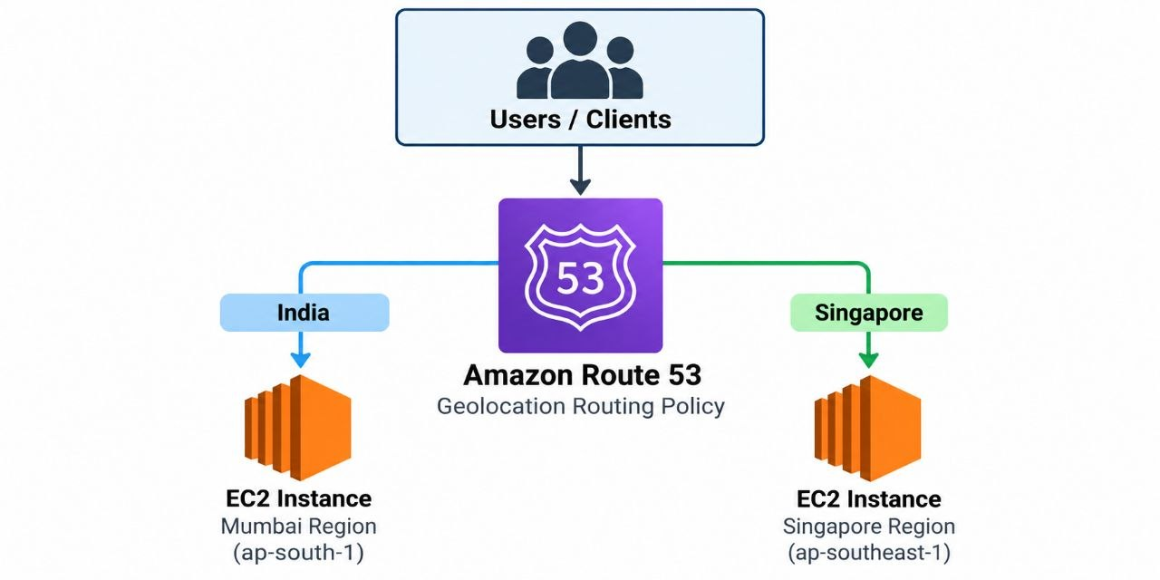

LAUNCH EC2 INSTANCE IN MUMBAI

1. create a instance
- name - primary-web-server
- ami - ubuntu
- instance_type - t3.micro
- key_pair - mayur
- sg - ssh/http
- user_data
sudo apt update
sudo apt install apache2 -y
echo '<h1>PRIMARY WEBSITE - MUMBAI</h1>' | sudo tee /var/www/html/index.html
sudo systemctl enable --now apache2
- launch ec2 instance

2.Allocate Elastic IP Address
- click on elastic ip address
- allocate elastic ip address
- associate IP with primary-web-server

LAUNCH EC2 INSTANCE IN SINGAPORE

create a instance
- name - secondary-web-server
- ami - ubuntu
- Instance_type - t3.micro
- key_pair - mayur
- sg - ssh/http
- user_data
sudo apt update
sudo apt install apache2 -y
echo '<h1>SECONDARY WEBSITE - SINGAPORE</h1>' | sudo tee /var/www/html/index.html
sudo systemctl enable --now apache2
- launch ec2 instance

2.Allocate Elastic IP Address
- click on elastic ip address
- allocate elastic ip address
- associate IP with secondary-web-server

ROUTE53

CREATE THE INDIA RECORD

click on record
- record name - geo
- record type - A
- value - (mumbai-elastic-ip-address)
- routing policy - Geolocation
- TTL - 60
- location - India
- Record ID - india-mumbai
- create record

CREATE THE SINGAPORE RECORD

click on record
- record name - geo
- record type - A
- value - (singapore-elastic-ip-address)
- routing policy - Geolocation
- TTL - 60
- location - singapore
- Record ID - Singapore
- create record

CREATE THE DEFAULT RECORD

click on record
- record name - geo
- record type - A
- value - (mumbai-elastic-ip-address)
- routing policy - Geolocation
- TTL - 60
- location - singapore
- Record ID - geo-default
- create record

TEST
http://geo.mayurcbz.space

Understand the routing
- India location - Mumbai
- Singapore location - Singapore
- other location – (default record – Mumbai)

LATENCY-BASED ROUTING FOR MULTI-REGION EC2 SERVERS

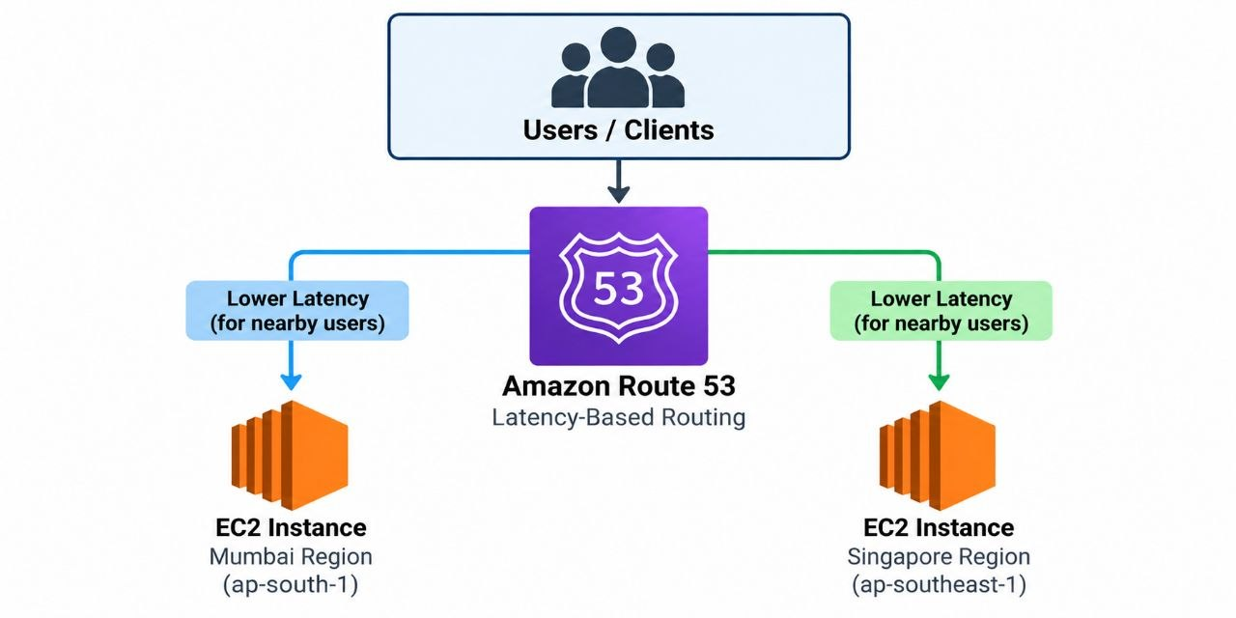

LAUNCH EC2 INSTANCE IN MUMBAI

create a instance
- name - primary-web-server
- ami - ubuntu
- instance_type - t3.micro
- key_pair - mayur
- sg - ssh/http
- user_data
sudo apt update
sudo apt install apache2 -y
echo '<h1>PRIMARY WEBSITE - MUMBAI</h1>' | sudo tee /var/www/html/index.html
sudo systemctl enable --now apache2
- Launch ec2 instance

2.Allocate Elastic IP Address
- click on elastic ip address
- allocate elastic ip address
- associate IP with primary-web-server

LAUNCH EC2 INSTANCE IN SINGAPORE

create a instance
- name - secondary-web-server
- ami - ubuntu
- instance_type - t3.micro
- key_pair - mayur
- sg - ssh/http
- user_data
sudo apt update
sudo apt install apache2 -y
echo '<h1>SECONDARY WEBSITE - SINGAPORE</h1>' | sudo tee /var/www/html/index.html
sudo systemctl enable --now apache2
- Launch ec2 instance

2.Allocate Elastic IP Address
- click on elastic ip address
- allocate elastic ip address
- associate IP with secondary-web-server

CREATE THE MUMBAI LATENCY RECORD

click on record
- record name - latency
- record type - A
- value - (mumbai-elastic-ip-address)
- routing policy - latency
- TTL - 60
- Region - mumbai
- Record ID - mumbai-latency
- create record

CREATE THE SINGAPORE LATENCY RECORD

click on record
- record name - latency
- record type - A
- value - (singapore-elastic-ip-address)
- routing policy - latency
- TTL - 60
- Region - singapore
- Record ID - singapore-latency
- create record

TEST
http://latency.mayurcbz.space

